Combinational and Sequential Optimization
In VLSI design, optimization techniques are crucial for enhancing the efficiency and performance of digital circuits. This document covers several key methods used to streamline both combinational and sequential logic.

Constant Propagation
Constant propagation is a compiler optimization technique that replaces variables with their constant values during the synthesis phase of VLSI design. This process significantly simplifies the circuit's logic and improves its performance.
The technique analyzes the design code to identify any variables assigned a constant value. Once found, these variables are replaced directly, allowing synthesis tools to simplify the underlying logic and reduce the overall circuit size.

Benefits
- Reduced Complexity: The resulting logic is simpler and more compact.
- Performance Improvement: Simpler logic leads to faster signal propagation and reduced delays.
- Resource Optimization: Fewer gates and flip-flops are required, saving valuable chip area.
State Optimization
State optimization is used to refine finite state machines (FSMs), improving their efficiency in integrated circuit (IC) design. This involves reducing the number of states, optimizing state encoding, and minimizing the logic required to implement the FSM.

How it is done:
- State Reduction: Equivalent states are merged using established algorithms to create a more compact FSM.
- State Encoding: Optimal binary codes are assigned to each state to simplify the combinational logic.
- Logic Minimization: Boolean algebra or automated tools are used to derive the most compact logic equations for state transitions and outputs.
- Power Optimization: Techniques like clock gating can be employed to reduce dynamic power consumption by disabling clocks to unused sections of the circuit.

Cloning
Cloning involves duplicating a logic cell or module to optimize a circuit's performance, reduce power consumption, or improve timing by balancing the electrical load or shortening long wires.

How It's Done
- Identify Critical Paths: Analysis tools are used to locate parts of the circuit that are limiting its speed.
- Duplicate the Target: The logic cell or module on the critical path is duplicated.
- Redistribute Connections: The original connections are split and rerouted to the cloned cells, balancing the load and reducing signal delays.
- Place and Route: The new cloned cell is physically placed and routed on the chip layout.
- Verify Improvement: The design is re-analyzed to confirm that timing and power have improved.

Retiming
Retiming is a sequential optimization technique that improves circuit performance by repositioning registers (flip-flops) without changing the circuit's overall functionality. This technique helps balance delays between logic stages to achieve a higher clock frequency.

How It's Done
- Graph Representation: The circuit is modeled as a directed graph where nodes represent combinational logic blocks and edges represent registers.
- Register Repositioning: Registers are moved across combinational logic blocks to balance the delays of different signal paths.
- Constraints Analysis: This process ensures that the repositioning maintains the circuit's functional equivalence and meets all timing constraints.
- Optimization: The final positions of the registers are adjusted to minimize the clock period and optimize for power.

Lab 1: Constant Propagation
Verilog Code:
Verilog
module opt_check (input a, input b, output y);
assign y = a ? b : 0;
endmodule
Explanation: This code implements a conditional assignment. If a is true (1), y is assigned the value of b. If a is false (0), y is 0.
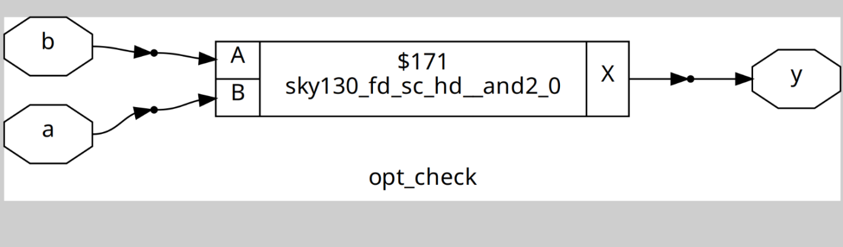

Lab 2: Constant Propagation
Verilog Code:
Verilog
module opt_check2 (input a, input b, output y);
assign y = a ? 1 : b;
endmodule
Code Analysis: This module acts as a simple multiplexer. The output y is 1 if the input a is true. Otherwise, y is assigned the value of input b.
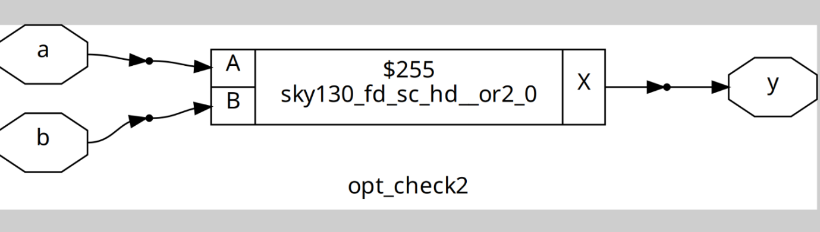

Lab 3: Logic Minimization
Verilog Code:
Verilog
module opt_check4 (input a, input b, input c, output y);
assign y = a ? (b ? (a & c) : c) : (!c);
endmodule
Functionality: This circuit has three inputs (a, b, c) and one output (y). The nested ternary logic can be simplified:
- If a = 1, the expression simplifies to (b ? (1 & c) : c), which further simplifies to (b ? c : c). In both cases, the output is c.
- If a = 0, the expression simplifies to !c.
- The overall logic simplifies to: y = a ? c : !c. This is equivalent to an exclusive-OR gate between a and c.
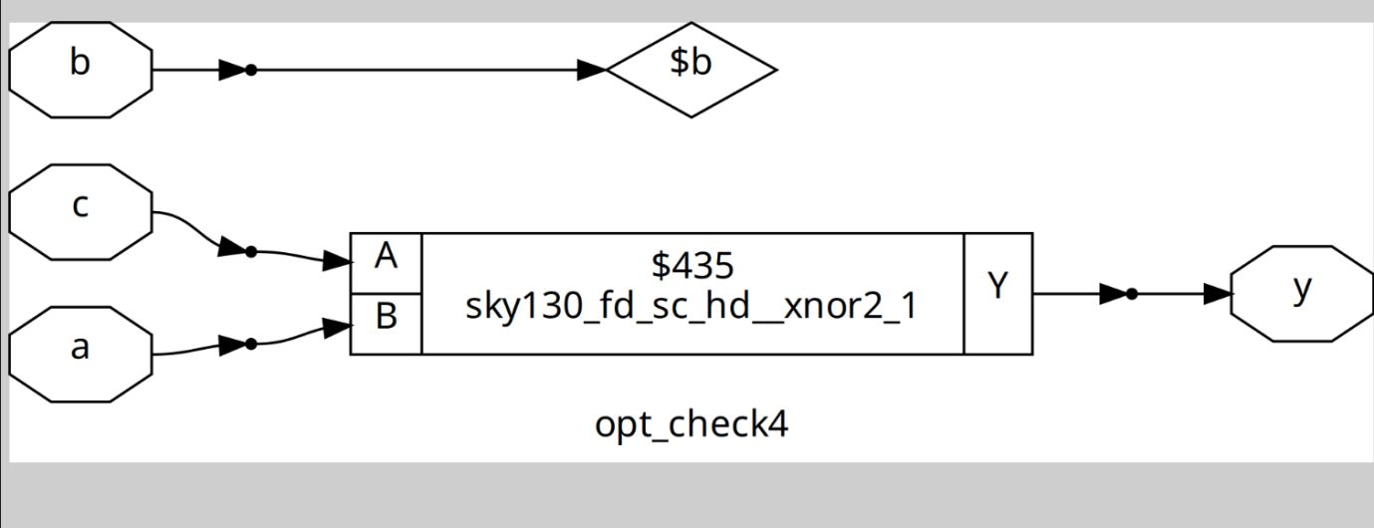

Lab 4: D Flip-flop with Constant Input
Verilog Code:
Verilog
module dff_const1 (input clk, input reset, output reg q);
always @(posedge clk, posedge reset) begin
if (reset)
q <= 1'b0;
else
q <= 1'b1;
end
endmodule
Functionality: This is a D flip-flop with an asynchronous reset. When reset is active, the output q is set to 0. When not in reset, the flip-flop loads a constant value of 1 on the positive edge of the clock.
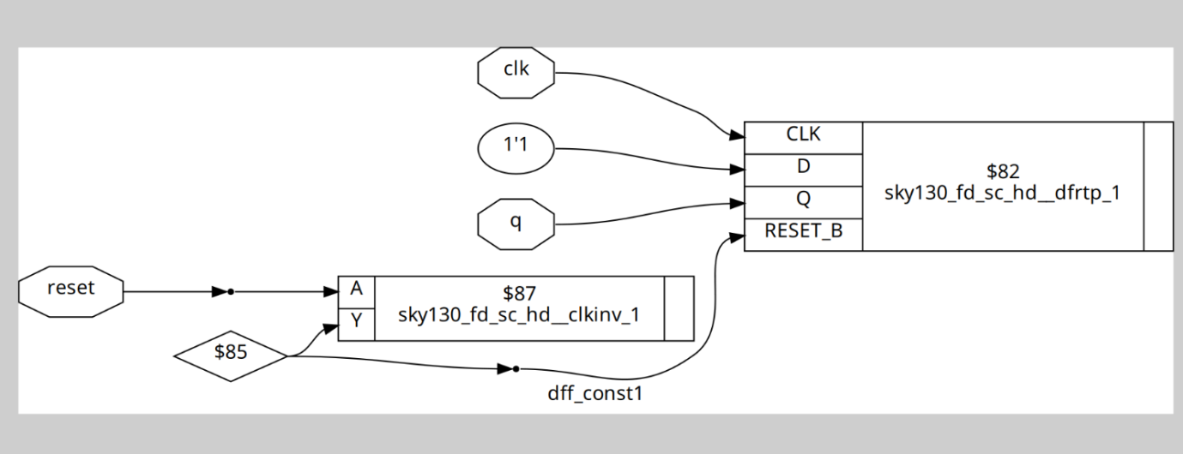

Lab 5: Constant D Flip-flop
Verilog Code:
Verilog
module dff_const2 (input clk, input reset, output reg q);
always @(posedge clk, posedge reset) begin
if (reset)
q <= 1'b1;
else
q <= 1'b1;
end
endmodule
Functionality: This D flip-flop is configured to always set its output q to 1, regardless of whether reset is active or a clock edge occurs. A smart synthesis tool would optimize this away, replacing the flip-flop with a simple hard-wired connection to VDD (logic 1).
